1. 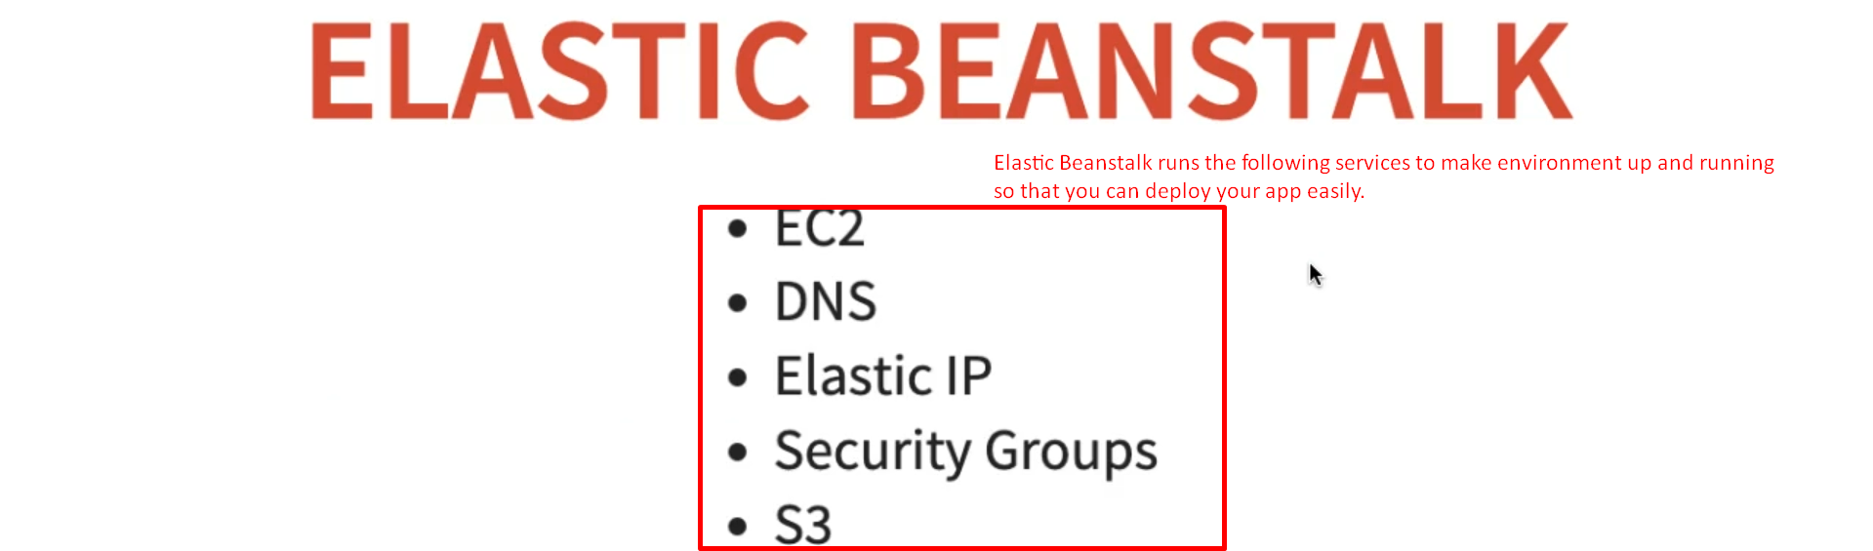
2. So far, we created Elastic Beanstalk environment which was really easy to create.
3. In this step, let’s look at some of the things the elastic Beanstalk does in the background to get the environment up and running.
4. The first service we will start with is EC2 🡺 Elastic Compute Cloud.
5. **EC2**: These are the **virtual servers** on which our apps are deployed.
   1. 
   2. 
   3. 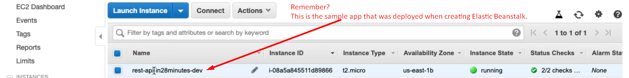
   4. EC2 is a web service to obtain virtual resources/servers in the cloud.  
      It supports a variety of resource configurations.  
      You can configure memory, CPU, Storage, Network Capacity etc. for your virtual server.  
      EC2 instances are charged by the amount of time, they are running.  
      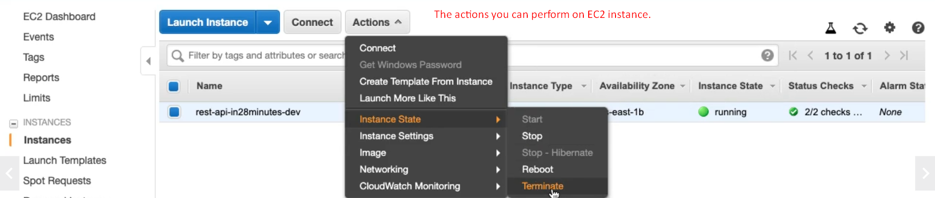
   5. 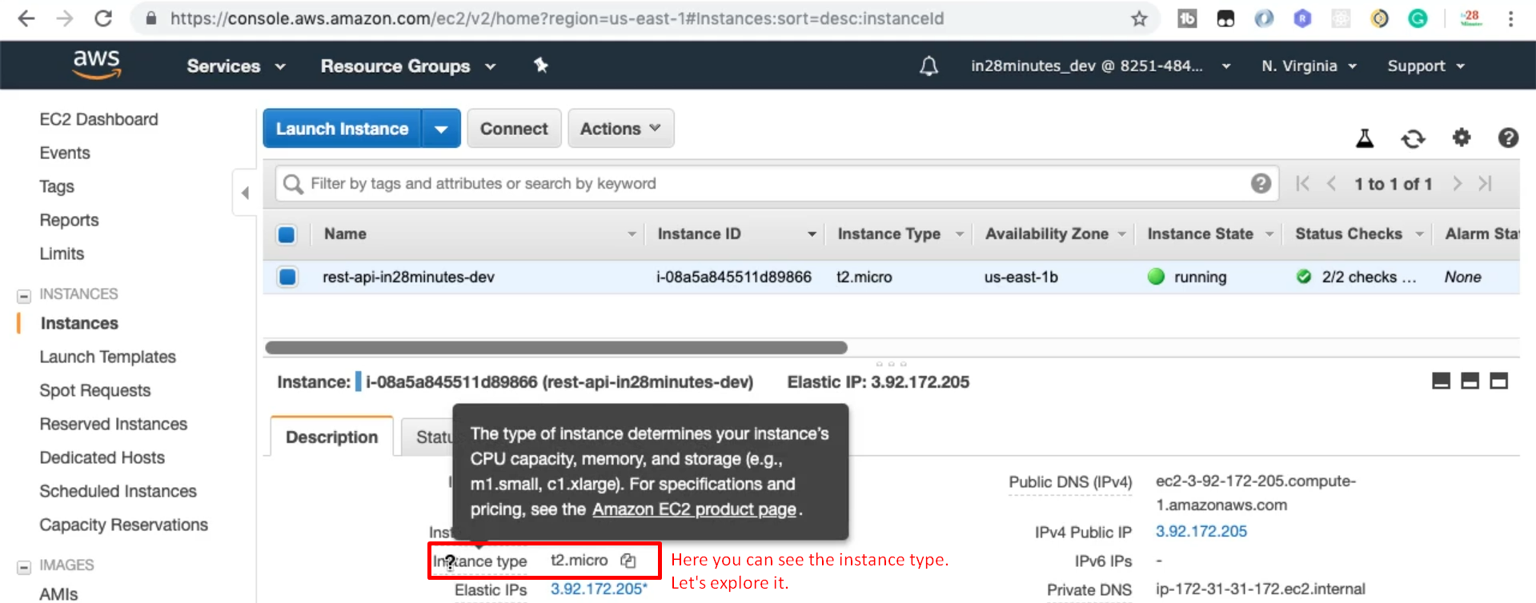  
      t2.micro  
      🡺 It is part of free tier.  
      🡺 For 1st 12 months from the date you created AWS account, you get 750Hours for free.